Internship Report – Day 2

Name: Krish Raj
Collage: Vidya Vihar Institute Of Technology, Maranga, Purnia, Bihar
Course: B.Tech (Computer Science Engineering)
Year: 2nd Year
Internship Title: Internship in Web Design
Company: Software Servies and Solution, Patna
Mentor: Sabiha Fatma
Day: 2
Date: 23 December 2025
Mode: Online
Objective of the Day
The main objective of Day 2 was to understand the basics of HTML and CSS, learn how web pages are structured, and explore Flexbox for creating responsive layouts.
Activities Performed
- Learned the basic structure of HTML, including tags such as <html>, <head>, <body>, <div>, <img>, <h1> – <h6>, and <p>.
- Studied CSS basics such as colors, fonts, margins, padding, and background styling.
- Understood how HTML and CSS work together to design web pages.
- Learned CSS Flexbox concepts like:
  - display: flex
  - flex-direction
  - justify-content
  - align-items
- A small project was given during the session to apply Flexbox concepts.
- Completed the given project during the session.
- As homework, created an improved web page inspired by the class project using HTML, CSS, and Flexbox.
- Designed sections such as header, navigation bar, faculty cards, and content layout.
Tools / Technologies Used
- HTML5
- CSS3
- CSS Flexbox
- Visual Studio Code
- Web Browser (Chrome)
Learning Outcomes
- Gained a clear understanding of how HTML structures a webpage.
- Learned how CSS improves the appearance and layout of a website.
- Understood the importance of Flexbox in responsive web design.
- Improved confidence in creating basic web layouts independently.
- Learned how to convert ideas into real webpage designs.
Challenges Faced
- Initially faced difficulty in aligning elements using Flexbox.
- Minor issues with spacing and responsiveness.
(These challenges were resolved by practicing and revising Flexbox properties.)
Project Work / Source Code
During Day 2, a small project based on HTML, CSS, and Flexbox was assigned during the session.
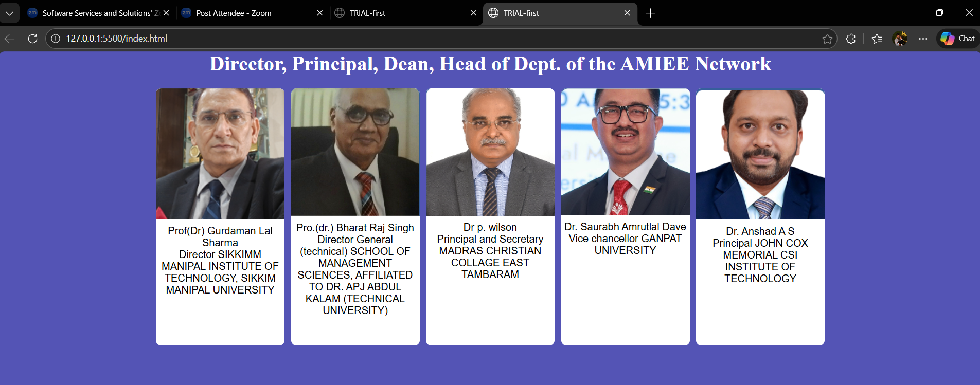
Additionally, I developed an improved webpage as homework, inspired by the class project, focusing on layout design, alignment, and responsiveness.
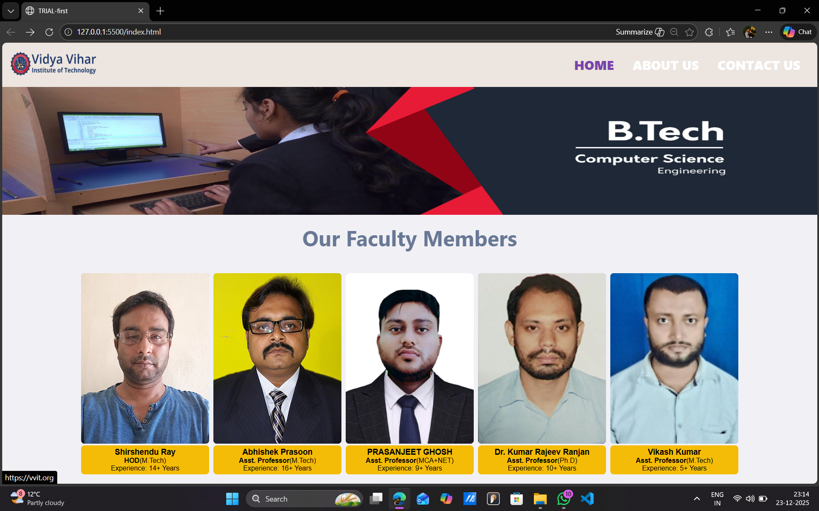

🔗 GitHub Repository (Source Code):
https://github.com/KrishRaj-0821/INTERNSHIP-I.git
Conclusion
Day 2 was highly practical and engaging. Learning HTML, CSS, and Flexbox helped me build structured and visually appealing web pages. The hands-on project and homework task strengthened my understanding of layout design and improved my confidence in web development. Uploading the project to GitHub also helped me practice version control and documentation.
Plan for Next Day
- Learn advanced CSS concepts
- Work on responsive designs
- Explore forms and layout improvements
Signature: Krish Raj
Mentor’s Signature: ____________________

